|  |  |
| --- | --- |
| **ch29.ReactJS - Map** | **Date: 22-02-2022** |

**Topics**

React Props Validation,

# React Props Validation

# React Map

A map is a data collection type where data is stored in the form of pairs. It contains a unique key. The value stored in the map must be mapped to the key. We cannot store a duplicate pair in the map(). It is because of the uniqueness of each stored key. It is mainly used for fast searching and looking up data.

In React, the ?map? method used to traverse and display a list of similar objects of a component. A map is not the feature of React. Instead, it is the standard JavaScript function that could be called on any array. The map() method creates a new array by calling a provided function on every element in the calling array.

### **Example**

In the given example, the map() function takes an array of numbers and double their values. We assign the new array returned by map() to the variable doubleValue and log it.

1. var numbers = [1, 2, 3, 4, 5];
2. **const** doubleValue = numbers.map((number)=>{
3. **return** (number * 2);
4. });
5. console.log(doubleValue);

## **In React, the map() method used for:**

1. Traversing the list element.

**Example**

1. **import** React from 'react';
2. **import** ReactDOM from 'react-dom';
4. function NameList(props) {
5. **const** myLists = props.myLists;
6. **const** listItems = myLists.map((myList) =>
7. <li>{myList}</li>
8. );
9. **return** (
10. <div>
11. <h2>React Map Example</h2>
12. <ul>{listItems}</ul>
13. </div>
14. );
15. }
16. **const** myLists = ['A', 'B', 'C', 'D', 'D'];
17. ReactDOM.render(
18. <NameList myLists={myLists} />,
19. document.getElementById('app')
20. );
21. export **default** App;

**Output**

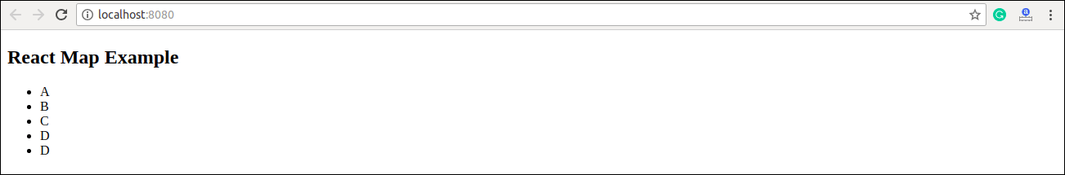

2. Traversing the list element with keys.

**Example**

1. **import** React from 'react';
2. **import** ReactDOM from 'react-dom';
4. function ListItem(props) {
5. **return** <li>{props.value}</li>;
6. }
8. function NumberList(props) {
9. **const** numbers = props.numbers;
10. **const** listItems = numbers.map((number) =>
11. <ListItem key={number.toString()}
12. value={number} />
13. );
14. **return** (
15. <div>
16. <h2>React Map Example</h2>
17. <ul> {listItems} </ul>
18. </div>
19. );
20. }
22. **const** numbers = [1, 2, 3, 4, 5];
23. ReactDOM.render(
24. <NumberList numbers={numbers} />,
25. document.getElementById('app')
26. );
27. export **default** App;

**Output**

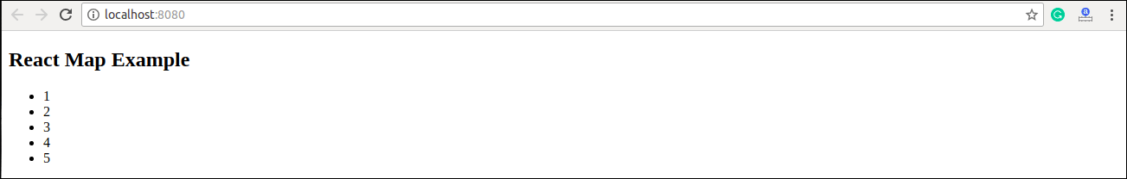

Next Topic[React Table](https://www.javatpoint.com/react-table)